Home Security Alert System using Raspberry PI

**Savitha K N1, Varsha C G2,Vidyavati3 ,Yashaswi G4**

B.E, Computer Science and Engineering, MSRIT, Banglore, India 1

B.E, Computer Science and Engineering, MSRIT, Banglore, India 2

B.E, Computer Science and Engineering, MSRIT, Banglore, India 3

B.E, Computer Science and Engineering, MSRIT, Banglore, India 4

Abstract **: This paper deals with the design and implementation of Home Security Alert System using Raspberry pi, PIR sensor and Fire Detection Sensors for mobile devices. It increases the usage of mobile technology to provide essential security to our homes and for other control applications. The proposed home security system captures information and transmits it via a Internet to a Smart phone using web application. Raspberry pi operates and controls motion detectors and video cameras for remote sensing and streams live video and records it for future playback. when motion is detected, The cameras automatically initiate recording and the Raspberry pi device alerts the owner of the possible intrusion having a smart phone. Raspberry- Pi has two main components interacting with each other: one is the Web Application that executes on the mobile device's browser and server-side scripts that run in a cloud which will be operated by the Raspberry Pi Hardware tool component.**

Keywords: USB cameras, PIR sensor ,Fire Detection Sensor, Raspberry Pi ,3G dongle, Smart phone

**I Introduction**

The Raspberry Pi is a series of [credit card](https://en.wikipedia.org/wiki/Credit_card)–sized [single-board computers](https://en.wikipedia.org/wiki/Single-board_computer). There are various surveillance systems such as camera, CCTV etc. In these types of surveillance systems, the person who is stationary and is located in that particular area can only view what is happening in that place .Whereas, here ,even if the user is moving from one place to another ,he/she can keep track of what is happening in that particular place. Also another advantage is that it offers privacy on both sides since it is being viewed by only one person .The other major advantage is that it is a simple circuit .the operating system used here is Raspbian OS. Raspbian OS has to be installed so that the image can be transmitted to the Smartphone.

**II Design**

I. **FUNCTIONAL DESCRIPTION**

The functions of the various components are given below:

*A. USB Camera:* USB Camera captures the image and sends it to the USBport of the Raspberry Pi board. The camera model usedhere is USB Camera model 2.0.

*B. Raspberry Pi****:*** Raspberry pi is a small credit-card sized computer capable of performing various functionalities such as in surveillance systems, military applications, etc. The variousfunctionalities of the components are given below

Thevarious components of Raspberry- Pi are

• *SD Card Slot* is used to install OS/booting/long term storage .The total memory of the SD card is about 8GB.

• *Micro USB Power Port* provides 700mA at 5A.

• *RCA Video Out* is connected to display if HDMI output is not used. It is mainly used to carry audio and video signals. They are otherwise called as A/V jacks.

• *Audio Out* Digital audio is obtained if HDMI is used to obtain stereo audio. Here analogue RCA connection is used.

• *Ethernet Port is* used to connect to the Internet. It also plays a role in updating, getting new software easier.

• *HDMI OUT(High Definition Multimedia Interface)* is used with HDTVs and monitors with HDMI input. Also HDMI-HDMI is used here.

• *BROADCOM BCM 2835*: It is otherwise defined as System on chip .It is a 700 MHz Processor. It has a Video core IV GPU.

• *GPIO* allows use to control and interact with real world.



*Fig 1:System Design*

II.**System ARCHITECTURE**

In the figure1,Raspberry Pi is connected to the USB camera with the help of USB port. In the PC Raspbian operating system is installed. Raspbian is a free operating system based on Debian optimized for the Raspberry Pi hardware. An operating system is the set of basic programs and utilities that make your Raspberry Pi run.

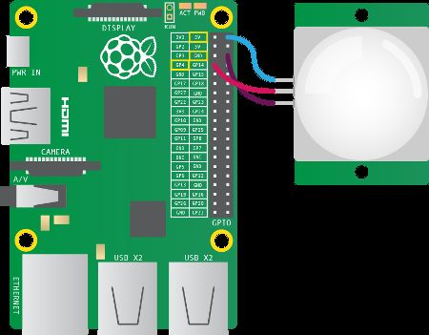

*Fig 2: Module*

Putty configuration is needed to install Raspbian OS.

Putty configuration is SSH and Telnet client. It is a open source software that is available with source code. And a minimum size of 2 GB SD card is required, but a 4 GB SD card or above is recommended. There is a Pi Store for exchanging programs.

o The Raspbian Server Edition is a stripped version with other software packages bundled as compared to the usual desktop computer oriented Raspbian.

o The Wayland display server protocol enable the efficient use of the GPU for hardware accelerated GUI drawing functions Raspbian for Robots - A fork of Raspbian for robotics projects with LEGO, Grove, and Arduino

III Implementation

**STEPS FOR THE PuTTY CONFIGURATION**

1. Obtain a copy of PuTTY pre-configured for use at Columbia

from the PuTTY download page.

2. Save the installer file to your download directory or desktop.

3. Double-click on the file PuTTY-install.exe to begin the installation.

4. At the **Choose Destination** screen, Click **Next** to accept the recommended default destination location for installing PuTTY.

5. Click **Next on the Select Program Folder** screen to select PuTTY as the recommended Program Folder name (**PuTTY** should already be displayed in the Program Folders text box).

6. Click **Finish** on the final screen to complete the installation

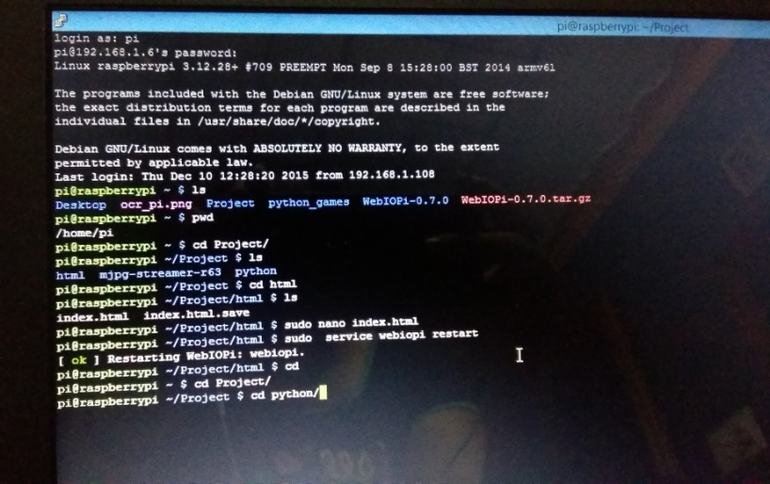

*Fig 3:PuTTY configuration*

ii. **STEPS TO INSTALL RASPBIAN OS**

In order to install Raspbian OS,first next out of box

software(NOOBS) has to be installed.

1.First step is to allocate the drive for installing OS

2.SD adaptor can also be used for this purpose

3.Download WINDISK 32 utility from source forge

project which is a zip file

4.Extract and run the zip file

5.Select the file and click run as administrator

6.Select the image file which was extracted above

7.Select the drive letter of the SD card in the device box

8.Click write and wait for write process to complete

9.Exit the image and eject the SD card

 *Fig 4:Installed Raspbian OS*

**IV.Testing and Comparison**

Since this is a security system, it is very important to ensure stable and error-free operation. The requirements are taken into account in the design phase, and verified by testing.



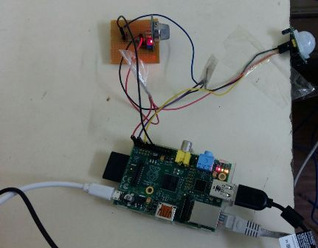

Fig5 Hardware connection

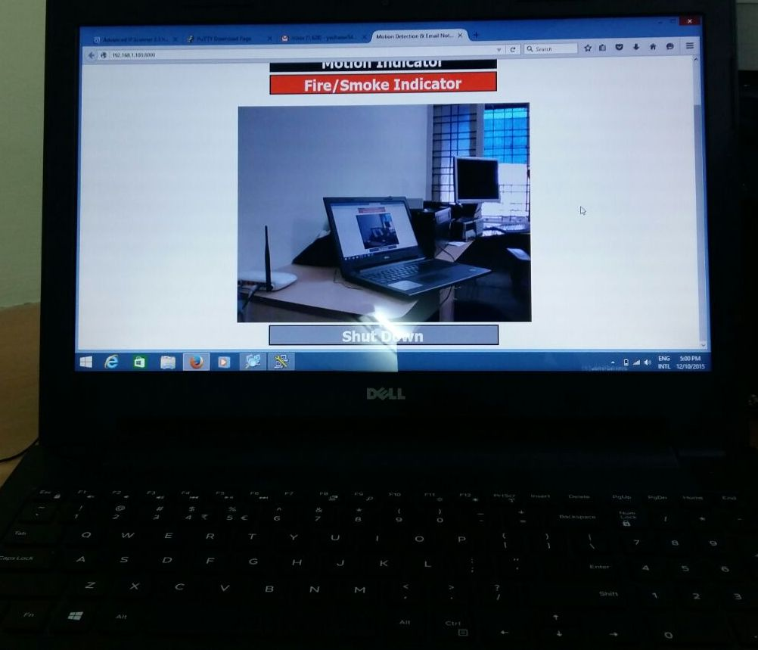Fig6 Testing video

**IV.RESULTS**

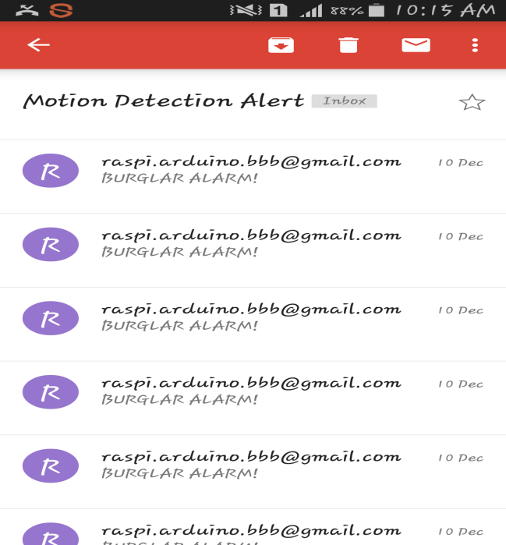

*Fig7 :email notification*

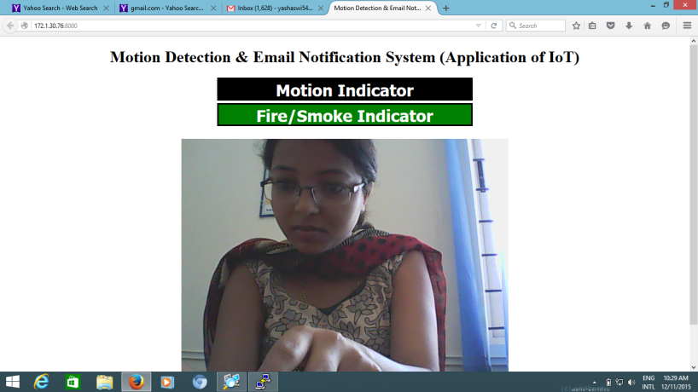

*Fig 6:Final Video*

**V.Scope and Future work**

It is advantageous as it offers reliability and privacy on both sides Future work is to locate the number of persons located exactly on that area and their position so that accurate information can be obtained on the receiver side. Neccesary action can be taken in short span of time in the case of emergency conditions such as elderly person falling sick, military areas, smart homes, offices, industries etc.

**VI.CONCLUSION**

Thus we have designed a smart surveillance system capable

of recording/capturing video/image and transmitting to a smart phone. And it offers only the person concerned to view the details.

**VI. REFERENCES**

[1]. [http://www.instructables.com/id/Home-Security-Email-Alert-](http://www.instructables.com/id/Home-Security-Email-Alert-System-using-Raspberry-P/)

System-using-Raspberry-P/

[2]. "U.S. Patent 613809: Method of and apparatus for controlling

mechanism of moving vessels and vehicles". United States Patent

and Trademark Office. 1898-11-08. Retrieved 2010-06-16.

[3].[http://www.smartcomputing.com/editorial/article.asp?article=articles%2](http://www.smartcomputing.com/editorial/article.asp?article=articles%252)F1995%2 Fmar95%2Fpcn0323%2Fpcn0323.asp retrieved 2010 09 02

[4]. William C. Mann (ed.) Smart technology for aging, disability and

independence : the state of the science, John Wiley and Sons, 2005 0

-471-69694-3, pp. 34-66

[5]. "Home automation costs". Totalavcontrol.co.uk. Retrieved 2010-02-18.